UML DIAGRAMS

Class Diagram for Bank Application

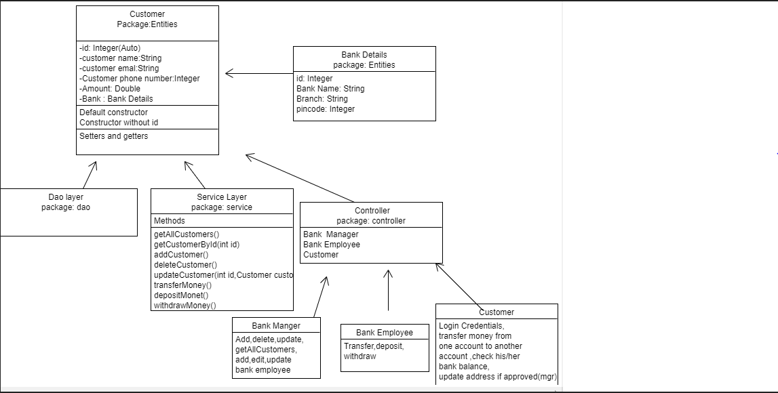

Use case diagram for Bank Application

